TASK 3- PLATFORMS
PART A-
HACKERRANK-

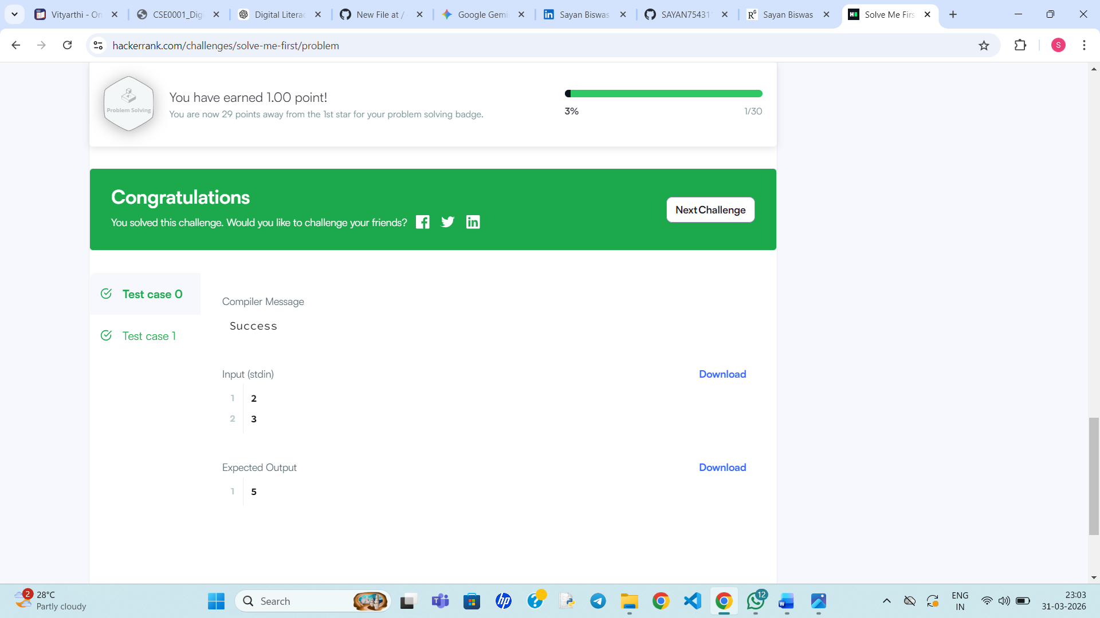

PART B-
GOOGLE FORM-
LINK- https://docs.google.com/forms/d/e/1FAIpQLSdg-fTfHM6LfHD5o2cz3ckBYjmb4_mGun2uHLA6pPLPEWIysw/viewform?usp=publish-editor

